**Heart’s Electrical Conduction System:**

1. **Action Potential** originates in the **sinoatrial** (SA) node and travel across the **wall of the atrium** from the **SA node** to the **atrioventricular** (AV) **node**.
2. AP passes slowly through the **AV node** to give the **atria time to contract**.
3. They then pass rapidly along the **bundle of His**, which extends from the atrioventricular node. The bundle of His divides into **right and left bundle** branches and **action potentials descend** rapidly to the **apex of each ventricle** along the bundle branches.
4. APs are carried by the **Purkinje fibers** from the bundle branches to the **ventricular walls**.
5. The rapid conduction from the **atrio-ventricular bundle** to the ends of the **Purkinje fibers** allows the ventricular muscle cells to contract in unison, providing a strong contraction.

**Electrocardiogram (ECG/EKG)**

**Electrocardiography** is the process of producing an **electrocardiogram** (**ECG** or **EKG**), a recording-a graph of voltage versus time-of the electrical activity of the heart using electrodes placed on the skin. These electrodes detect the small electrical changes that are a consequence of cardiac muscle depolarization followed by repolarization during each cardiac cycle (heartbeat).

In a conventional 12-lead ECG, ten electrodes are placed on the patient's limbs and on the surface of the chest. The overall magnitude of the heart's electrical potential is then measured from twelve different angles ("leads") and is recorded over a period of time (usually ten seconds). In this way, the overall magnitude and direction of the heart's electrical depolarization is captured at each moment throughout the cardiac cycle.

There are three main components to an ECG: the P wave, which represents the depolarization of the atria; the QRS complex, which represents the depolarization of the ventricles; and the T wave, which represents the repolarization of the ventricles.

During each heartbeat, a healthy heart has an orderly progression of depolarization that starts with pacemaker cells in the sinoatrial node, spreads throughout the atrium, and passes through the atrioventricular node down into the bundle of His and into the Purkinje fibers, spreading down and to the left

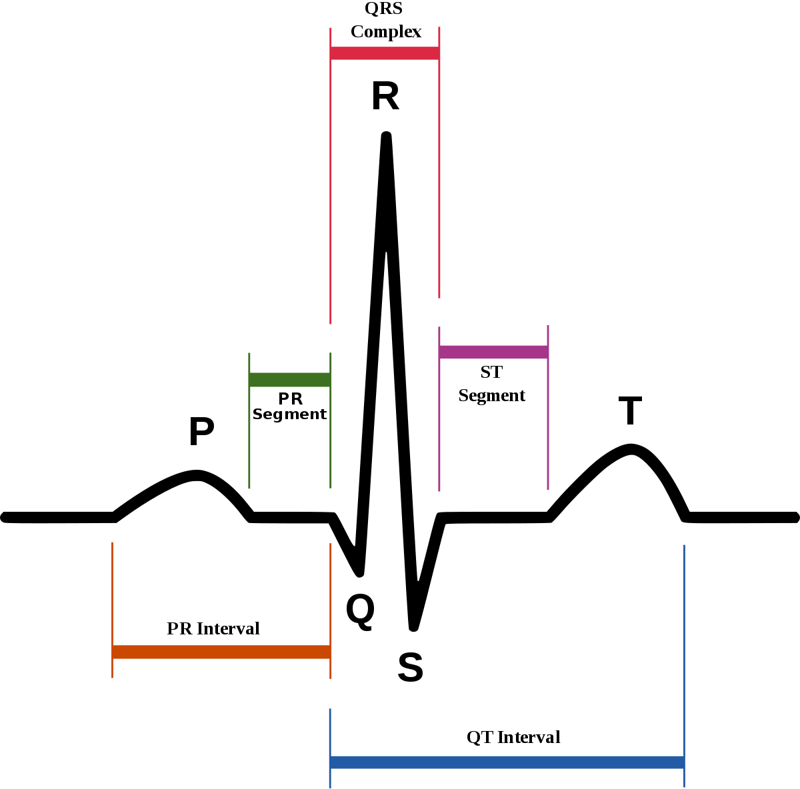

throughout the ventricles. This orderly pattern of depolarization gives rise to the characteristic ECG tracing. To the trained clinician, an ECG conveys a large amount of information about the structure of the heart and the function of its electrical conduction system. Among other things, an ECG can be used to measure the rate and rhythm of heartbeats, the size and position of the heart chambers, the presence of any damage to the heart's muscle cells or conduction system, the effects of heart drugs, and the function of implanted pacemakers.

### **How the Electrical Conduction Through the Heart Creates the ECG:**

* **P Wave:** the depolarization being generated in and spreading through the Sinoatrial node. The SA node is too small for its depolarization to be detected on most ECGs.  The depolarization travels through the atria, towards the Atrioventricular node. The depolarization travels through the largest amount of tissue in the atria, which creates the highest point in the P wave.
* **PR Segment:** Depolarization travels through the AV node. Like the SA node, the AV node is too small for the depolarization of its tissue to be detected on most ECGs. This creates the flat PR segment.
* **Q Wave:** The action potential starts traveling down the left bundle branch about 5 milliseconds before it starts traveling down the right bundle branch. This causes the depolarization of the interventricular septum tissue to spread from left to right. This gives rise to a negative deflection after the PR interval, creating a Q wave.
* **R Wave:** Following depolarization of the interventricular septum, the depolarization travels towards the apex of the heart, which creates the R wave.
* **S Wave:** Then the depolarization travels throughout both ventricles from the apex of the heart, following the action potential in the Purkinje fibers. This phenomenon creates a negative deflection in all three limb leads, forming the S wave on the ECG.

Repolarization of the atria occurs at the same time as the generation of the QRS complex, but it is not detected by the ECG since the tissue mass of the ventricles is so much larger than that of the atria.

* **ST segment:** Ventricular contraction occurs between ventricular depolarization and repolarization. During this time, there is no movement of charge, so no deflection is created on the ECG. This results in the flat ST segment after the S wave. This indicates the plateau phase of action potential.
* **T Wave:** The epicardium is the first layer of the ventricles to repolarize, followed by the myocardium. The endocardium is the last layer to repolarize. The plateau phase of depolarization has been shown to last longer in endocardial cells than in epicardial cells. This causes repolarization to start from the apex of the heart and move upwards. This creates the T wave.
* **U wave:** The U wave is hypothesized to be caused by the repolarization of the interventricular septum. It normally has a low amplitude, and even more often is completely absent.

**ECG Theory:**

* depolarization of the heart *towards* the positive electrode produces a positive deflection
* depolarization of the heart *away* from the positive electrode produces a negative deflection
* repolarization of the heart *towards* the positive electrode produces a negative deflection
* repolarization of the heart *away* from the positive electrode produces a positive deflection

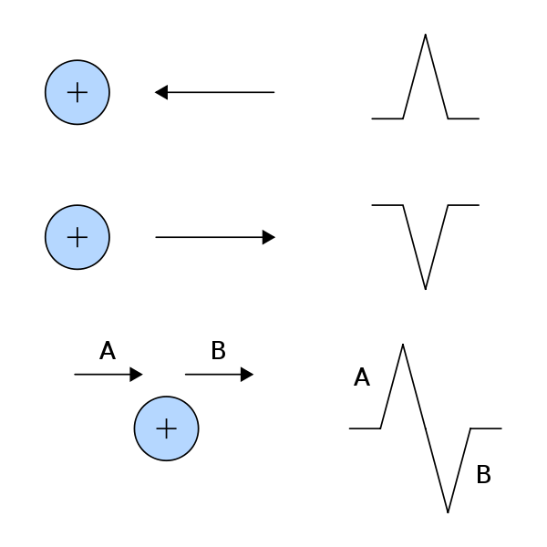

## Electrodes and leads:

## Electrodes are the actual conductive pads attached to the body surface. Any pair of electrodes can measure the electrical potential difference between the two corresponding locations of attachment. Such a pair forms *a lead*. However, "leads" can also be formed between a physical electrode and a *virtual electrode,* known as *the Wilson's central terminal*, whose potential is defined as the average potential measured by three limb electrodes that are attached to the right arm, the left arm, and the left foot, respectively.

## Commonly, 10 electrodes attached to the body are used to form 12 ECG leads, with each lead measuring a specific electrical potential difference.

## Leads are broken down into three types: limb; augmented limb; and precordial or chest. The 12-lead ECG has a total of three *limb leads* and three *augmented limb leads* arranged like spokes of a wheel in the coronal plane (vertical), and six *precordial leads* or *chest leads* that lie on the perpendicular transverse plane (horizontal)

**Electrode (10) placement for 12 lead ECG:**

|  |  |
| --- | --- |
| Electrode Name | Electrode placement |
| RA | On the right arm, avoiding thick muscle. |
| LA | In the same location where RA was placed, but on the left arm. |
| RL | On the right leg, lower end of inner aspect of calf muscle. (Avoid bony prominences) |
| LL | In the same location where RL was placed, but on the left leg. |
| V1 | In the fourth intercostal space (between ribs 4 and 5) just to the right of the sternum (breastbone) |
| V2 | In the fourth intercostal space (between ribs 4 and 5) just to the left of the sternum. |
| V3 | Between leads V2 and V4. |
| V4 | In the fifth intercostal space (between ribs 5 and 6) in the mid-clavicular line. |
| V5 | Horizontally even with V4, in the left anterior axillary line. |
| V6 | Horizontally even with V4 and V5 in the mid-axillary line. |

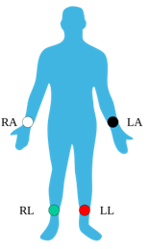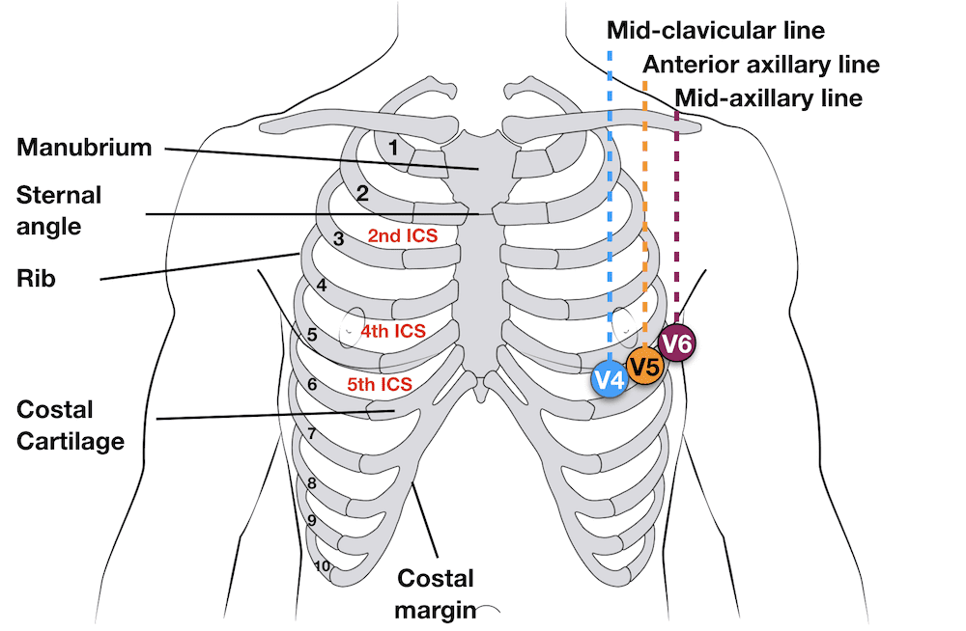

The common virtual electrode, known as the Wilson's central terminal (VW), is produced by averaging the measurements from the electrodes RA, LA, and LL to give an average potential of the body:

Vw=1/3(RA+LA+LL)

In a 12-lead ECG, all leads except the limb leads are unipolar (aVR, aVL, aVF, V1, V2, V3, V4, V5, and V6). The measurement of a voltage requires two contacts and so, electrically, the unipolar leads are measured from the common lead (negative) and the unipolar lead (positive).

**Limb Leads:**

Leads I, II and III are called the *limb leads*. The electrodes that form these signals are located on the limbs – one on each arm and one on the left leg. The limb leads form the points of what is known as Einthoven's triangle.

* Lead I is the voltage between the (positive) left arm (LA) electrode and right arm (RA) electrode: I =LA-RA
* Lead II is the voltage between the (positive) left leg (LL) electrode and the right arm (RA) electrode: II=LL-RA
* Lead III is the voltage between the (positive) left leg (LL) electrode and the left arm (LA) electrode: III=LL-LA

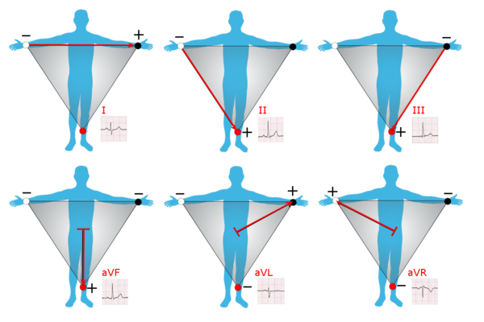

**Augmented Limb Leads:**

Leads aVR, aVL, and aVF are the *augmented limb leads*. They are derived from the same three electrodes as leads I, II, and III, but they use Goldberger's central terminal as their negative pole. Goldberger's central terminal is a combination of inputs from two limb electrodes, with a different combination for each augmented lead. It is referred to immediately below as "the negative pole".

* Lead *augmented vector right* (aVR) has the positive electrode on the right arm. The negative pole is a combination of the left arm electrode and the left leg electrode:

aVR= RA-1/2(LA+LL)= 3/2(RA-Vw)

* Lead *augmented vector left* (aVL) has the positive electrode on the left arm. The negative pole is a combination of the right arm electrode and the left leg electrode:

aVL=LA-1/2(RA+LL)=3/2(LA-Vw)

* Lead *augmented vector foot* (aVF) has the positive electrode on the left leg. The negative pole is a combination of the right arm electrode and the left arm electrode:

aVF=LL-1/2(RA+LA)=3/2(LL-Vw)

**Precordial chest leads:**

The *precordial leads* lie in the transverse (horizontal) plane, perpendicular to the other six leads. The six precordial electrodes act as the positive poles for the six corresponding precordial leads: (V1, V2, V3, V4, V5, and V6). Wilson's central terminal is used as the negative pole.

|  |  |
| --- | --- |
|  |  |